
Cryptography (CYB270) project

Prepared by:

Ibrahim Al-Sobhi – 4500410
Ibrahim Al-Amari – 4501857
Mohammed Al-Qahtani – 4500969
Samer Al-Harbi – 4500146
Ghalib Al-Harbi – 4501142

Introduction:
In the age of cloud processing, secure data storage and sharing are the biggest security issues. To get around this, we proposed a secure client-side encrypted file vault supported with a robust Key Encrypting Key (KEK) architecture and a "Zero-Knowledge" cloud server. The solution is designed to integrate AES-256 for confidentiality and HMAC-SHA256 for strict data integrity. It satisfies the CIA triad by isolating encrypted payloads from the cryptographic keys managed locally, while working with mass files efficiently through 4KB data chunks. This architecture guarantees high performance, scalability, and tamper-proof cloud storage, utilizing secure Link-Based Sharing to allow password-less file distribution without compromising the vault's security.

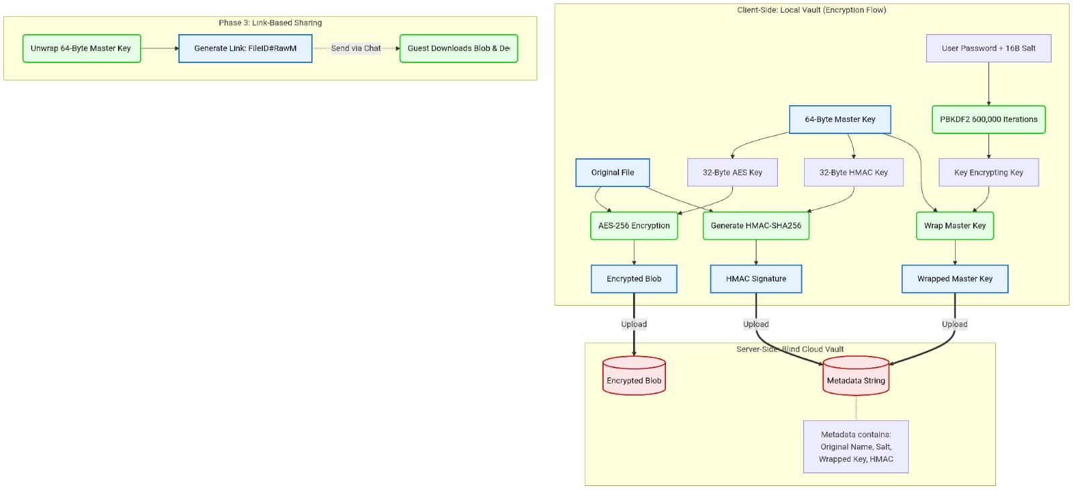

Design model:

Our secure file vault is built on an advanced Symmetric Key Wrapping Architecture. This model allows us to logically separate the encrypted data from the key management mechanism. The architecture is split into two main domains:
2.1 Client-Side: We ensured that the encrypted files are absolutely independent of the user's main password by using a multi-layered key hierarchy.

​2.1.1 Secure Key Wrapping & Link-Based Sharing: We designed a dual-layer key structure to ensure secure isolation:
Master File Key Generation: For every file, a unique 64-byte random key is generated. This key is split into two 32-byte halves: one for AES-256 encryption and one for HMAC-SHA256 integrity signing.

​Key Encrypting Key: We derive a KEK from the user’s password using the PBKDF2 algorithm (with 600,000 iterations and a secure 16-byte salt). The 64-byte Master File Key is then wrapped (encrypted) using this KEK before being sent to the server.

​Link-Based Sharing: Instead of complex asymmetric keys, sharing is achieved by locally unwrapping the Master File Key and embedding it securely into a Share URL (Base64URL encoded). This grants the recipient direct decryption capabilities without needing the owner's password or server intervention.

2.1.2Integrity-First Architecture (HMAC):
HMAC-SHA256 Signature: To prevent sophisticated tampering, the system generates a cryptographic HMAC signature of the original file using the dedicated 32-byte HMAC key. This ensures that an attacker cannot secretly modify the file and recalculate a valid checksum.
2.2 Cloud Server (Untrusted Environment) The cloud We designed the cloud server to function merely as a "blind vault." Its only job is to handle storage coordination, meaning it has absolutely zero visibility into the data it holds.
​Logical Separation: On the server side, we just store the encrypted file blobs right alongside a metadata string (which holds the salt, the wrapped master key, and the HMAC signature). The server holds onto all of this without having any clue what the data actually means.
​True Zero-Knowledge: At no point does the server ever see the original files, the user's password, or the raw encryption keys. Because of this setup, even if an attacker manages to fully compromise the server, all they would get their hands on is useless scrambled text and tightly locked keys they can't use.

Implementation:
This section explains how a file passes through our cryptographic platform. We decompose the architecture into three main segments: Upload, Download, and Secure Sharing.
3.1 Phase: Upload and Encryption
Once selected for upload, the system ensures the file is completely secured locally. The encryptAndUpload function handles this securely:
Step 1: Generating the 64-byte Master Key: A SecureRandom instance generates 64 bytes. It is immediately split: bytes 0-32 become the AES key, and bytes 32-64 become the HMAC key.
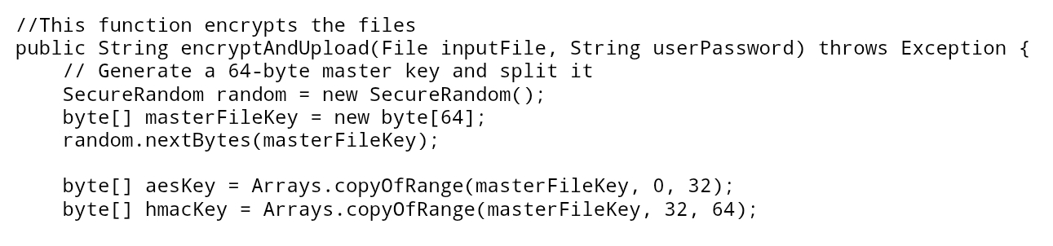

Step 2: Payload Encryption & HMAC Signature: The system initializes an AES/ECB/PKCS5Padding cipher, encrypts the file in 4KB chunks, and then computes the HMAC-SHA256 signature.
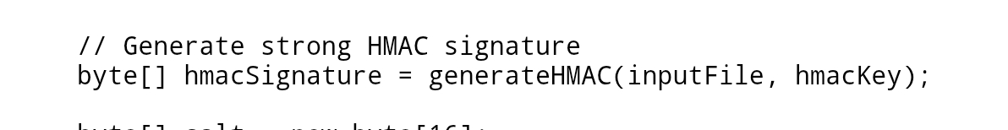

Step 3 :Master Key Wrapping (PBKDF2): A 16-byte random salt is generated. The PBKDF2 algorithm runs 600,000 iterations to derive the KEK. The 64-byte Master Key is securely encrypted using this KEK .
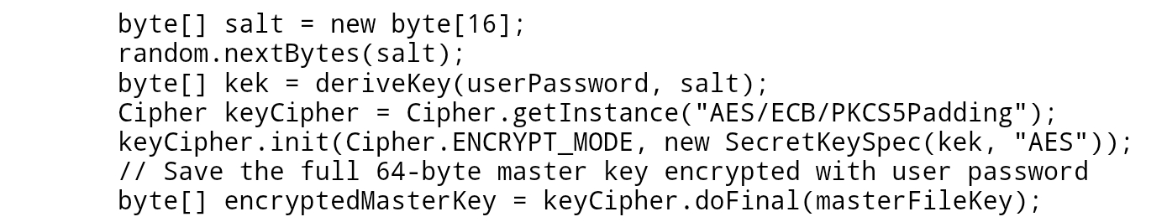

Phase : Download, Decryption, and Verification3.2
When the user downloads their personal file, the system acts as a final gatekeeper to guarantee integrity via the downloadPersonalFile function:
Step 4: KEK Derivation & Unwrapping: Using the user's password and the downloaded salt, the system recalculates the KEK via PBKDF2. It then decrypts the wrapped 64-byte Master Key.
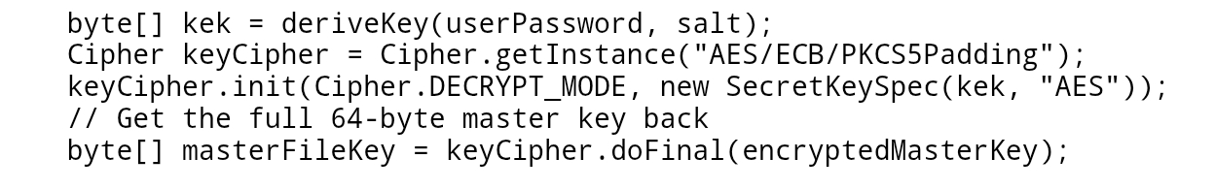
Step 5: HMAC Gatekeeper Verification: The system decrypts the file payload to disk. Before releasing it to the user, it calculates a new HMAC over the decrypted file. If it doesn't match perfectly, it auto-deletes the corrupted file.
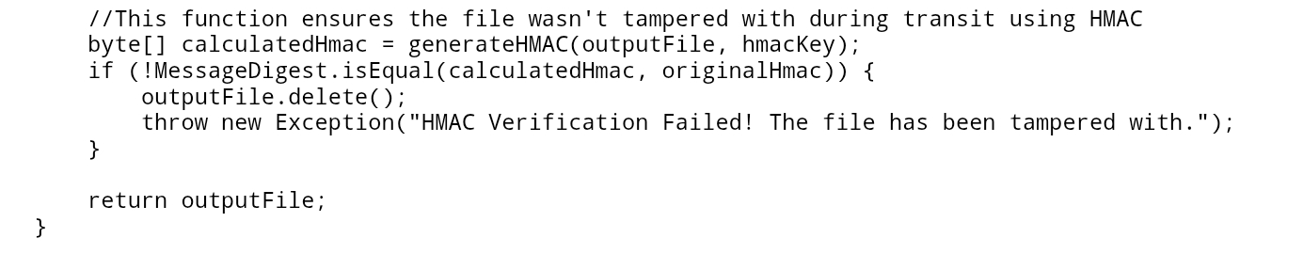

3.3Phase: Secure Link-Based File Sharing
The sharing mechanism enables users to grant access to specific files dynamically without asymmetric keys:
Step 6: Share Link Generation: The system derives the KEK, unwraps the Master Key locally, encodes it using a URL-safe Base64 encoder, and appends it to the File ID.
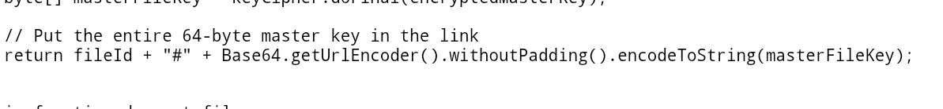

Step 7: Guest Access: When a guest uses this code in downloadSharedFile, the system bypasses the password step entirely. It parses the Master Key directly from the link and immediately proceeds to Decryption and HMAC Verification.
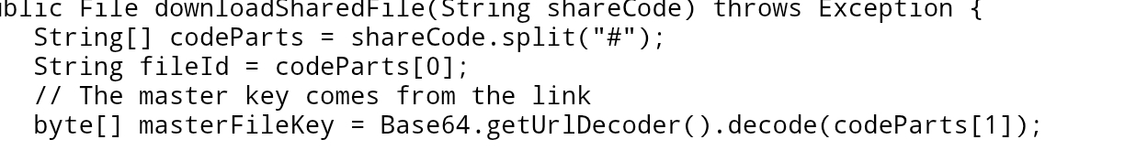

Performance and Overhead Analysis:
4.1 Computational Overhead :
The PBKDF2 key derivation function (600,000 iterations) introduces an intentional, slight delay during login and file operations. While virtually unnoticeable to the user, it renders brute-force and dictionary attacks computationally impracticable.
4.2 Storage Overhead :
Our solution introduces very low storage overhead. The encrypted file is identical in size to the original (plus minimal padding), and the metadata string stored on the database adds only a few kilobytes per file.

4.3 Memory Overhead (Chunked Efficiency)
Encrypting massive files typically causes Out-of-Memory crashes. We solved this by strictly processing file streams in 4KB blocks (byte[] chunk = new byte[4096]). The memory overhead remains flat and ultra-efficient whether handling a 1MB text file or a 1GB video.

System Testing:

5.1 testing Confidentiality.
Methodology: We inspected the server’s database (fileDatabase) and local files during an active session.
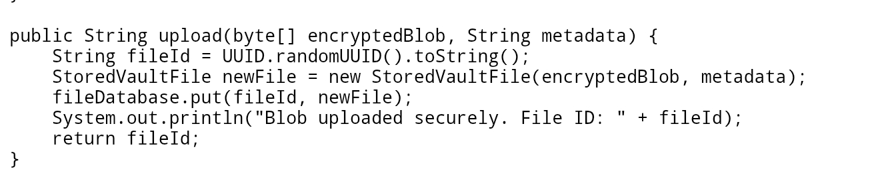
Result: Uploaded files on the server were entirely unreadable ciphertext. The Master Keys were heavily wrapped, proving that a compromised server cannot breach user data confidentiality.

5.2 Testing Integrity:

Methodology :We actively simulated a Man-in-the-Middle (MitM) or database corruption attack. If a single byte of the encrypted payload is altered, the resulting decrypted plaintext becomes corrupted.
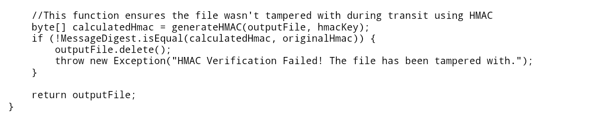
Result: Upon attempting to decrypt a tampered file, our generate HMAC function detected the mismatch between the original HMAC signature and the tampered payload. The system successfully blocked access, triggered an "Integrity Check Failed" UI alert, and auto-deleted the corrupted output.

5.3 Usability:

Methodology: We assessed ease of use for a non-technical user, avoiding complex command-line key management.

Result: The JavaFX Graphical User Interface (GUI) abstracts all complex logic. Users simply click "Upload," "Download," and "Generate Share Link." All underlying operations—such as PBKDF2 derivation, HMAC signing, and

Conclusion:

​Building this Java app was a great way to apply cryptography concepts in a real project. We focused on making a secure file vault from the start. To do this, we used AES-256 to encrypt the files and HMAC to catch any tampering. We also built a link-based sharing feature instead of relying on complex key systems. This kept our code clean and meant users never had to expose their passwords. When we tested the app, the server only saw scrambled data. Everything stayed private. We hit all the security targets we set out to achieve.

